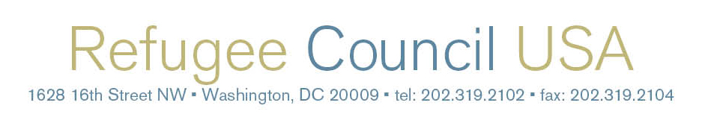

Toolkit for August 2017
Local Congressional Visits:

Protecting Resources for

Refugee Protection & Resettlement

Table of Contents

The Power of Advocacy…………………………..............................................................1

Where to Start: Teambuilding…………………................................................................2

Refugee Community Advocacy Week: July 31-September 4..........................................3

Action Alert: Stand Up for Refugee Protection & Resettlement………...........................4

Messaging Guidance & Talking Points............................................................................9

Backgrounders: Presidential Determination & Federal Funding for FY 2018………….11

Employer Roundtable....................................................................................................18

Media & Outreach Resources.......................................................................................19

Sample Letter to Send your Members of Congress......................................................22

Sample Letter to Send to Your State and Local Leaders..............................................23

Sample Local Welcoming Resolution............................................................................24

Sample Letter for Local Leaders to Send to the White House……………....................25

Resources & Contact Information for Advocacy Staff...................................................26

The Power of Advocacy

As refugees and friends of refugees, we know the challenges newcomers face and the need for improved policies to help refugees rebuild their lives in the United States.

Be an Advocate
Developing relationships and educating your policy makers are necessary steps to winning welcoming policies and attitudes toward refugees. A powerful constituent visit involves impacted communities and allies who join together. Having a team of refugee leaders, resettlement staff, volunteers, employers, faith groups, and other community members who meet regularly is essential in building meaningful relationships with policy makers. It is important that policy makers understand that their constituents care about refugees, and that refugees are their constituents — they live, work, and contribute in their communities, obtain U.S. citizenship, and vote. As our local, state, and national leaders consider proposals that will impact refugees, the time is now to urge them to stand with those seeking safety.

Your Voice Matters
Your story as a refugee, staff member, or supporter of refugee resettlement is your most important qualification as an advocate. Talk about the way your community welcomes refugees and the positive contributions refugees make to your community. Refugees, resettlement staff, faith leaders, employers, military veterans, and supportive community members are constituents of local, state, and national elected leaders who regularly make policy decisions that impact refugees. When policy makers know that their constituents care about refugees, they will increasingly vote to support refugee protection and resettlement, as well as productive policies that help refugees. It's important to note that 501(c)3 organizations can confidently educate policy makers about who refugees are and how policy proposals will impact their community. The IRS holds that 501(c)3 organizations can take positions on public policy issues, and that lobbying is acceptable, as long as it is not a substantial part of the organization’s work and/or is less than 20% of a non-profit’s budget. There are also special permissions for religious groups.

Engaging National and State Elected Leaders
At the national and state levels, individuals who oppose refugee resettlement are making their voices heard loudly and frequently to policy makers. These groups utilize anti-refugee, anti-immigrant, and anti-Muslim rhetoric and draft legislation to engender fear and foster hostile atmospheres for newcomers. More than 80 bills have been introduced in the U.S. Congress that would dismantle or significantly damage the U.S. refugee resettlement program. In 2015, 31 governors voiced opposition to resettling Syrian refugees and more than 50 anti-refugee proposals were introduced across 19 state legislatures in 2016. (Only one of these proposals passed, thanks to everyone’s hard work.) In 2017, we are facing at least 34 anti-refugee proposals across 18 states, but we have also seen 29 pro-refugee proposals introduced in 18 states. It is critical that policy makers hear from refugees themselves and supportive community members. We want policy makers to support positive legislation and oppose proposals that would turn our backs on refugees and violate our values of welcome and hospitality.

Engaging Local Policy Makers

Efforts to stop refugee resettlement in certain communities have been gaining traction, making it critical for local policy makers to hear from us and affirm that they welcome refugees. There are positive proposals that local elected officials can adopt to affirm the importance of resettlement and foster communities of welcome. City, municipal, and other local councils and commissions need to hear that their communities stand ready to help refugees integrate and thrive. Cities and counties across the nation have passed resolutions affirming they are welcoming, inclusive, and ready to accept refugees of all backgrounds, countries of origin, and faiths. Urge your local leaders to adopt welcoming resolutions that extend hospitality to refugees and all newcomers. Organizing community members around a welcoming resolution reflects a core American belief in the dignity of every person, lifts up diversity as a community’s strength, and cultivates an environment of inclusion. Local officials can also write supportive public letters to the White House, Department of State, and Congress. Click here for to see a framework one community developed to assess itself and facilitate welcome and inclusiveness of refugees and immigrants.

Where to Start: Teambuilding

The art of teambuilding is a critical component to advocacy. Teambuilding brings together diverse voices – such as resettlement staff, refugee leaders, faith leaders, and others – who speak to the importance of welcome and helping refugees integrate and thrive from several perspectives. This is how you can get started in creating and sustaining teams of people who can take action together for change.

Visualizing Teambuilding

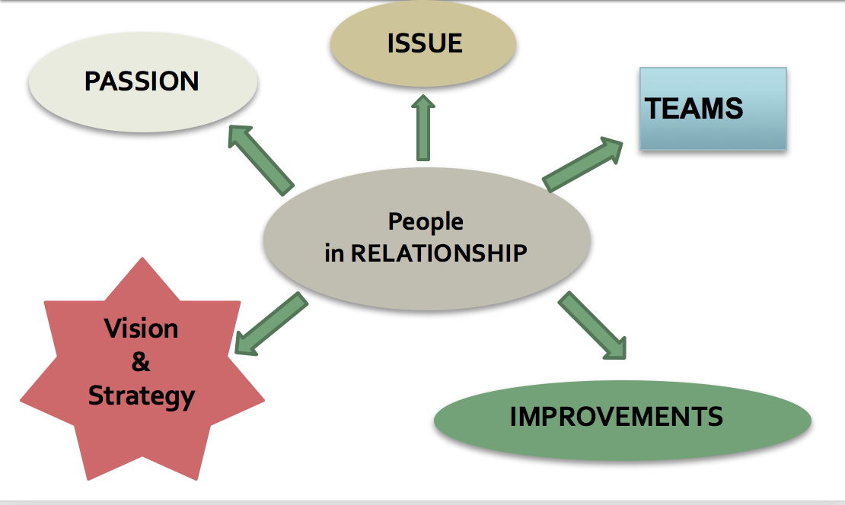

How Do I Build a Team?

Step 1: Internal Assessment

What are you passionate about? Why? What in your life journey has brought about this passion?

What policy changes (national and local) would you and your community like to see?

How could you see your community working to be part of bringing that change about?

What does being an “advocate” mean to you?

Step 2: One on One Relationship Building

Face to face meeting in a mutually preferred location

Intentional conversation, not an interview

Listening for passion, vision, stories

Work together to identify other people who would be interested in joining you

Each agree to reach out to people who share your vision and help build / energize a team

Step 3: Grow Your Team
Who else might care and be interested?
Ask each person to reach out to 3-5 more people and have one-on-one meetings
Set a timeline for a team meeting

Step 4: Bring the Team Together
Goal: bring together a solid group of 8-20 people
Create a common vision: what are our hopes and expectations?
Create an action plan: How do we build toward bringing that vision to life?
Who are natural allies who can be energized into being advocates and champions?
Identify next steps, including ways to engage with policy makers and other influential people.

For more information on how to engage in organizing and teambuilding, click here.
Connect with refugee and immigrants’ rights group near you: www.informedimmigrant.com/organizations/.

Refugee Community Advocacy Month: July 31-September 4

Who You Are. Why You Care. What You Want.
It is more important than ever to meet with your local, state, and national policy makers to educate them about the vital role that refugees and all newcomers play in your communities. Because the process of change takes time, meetings with policy makers should be viewed as part of a continuing process of gathering and sharing information, building relationships, and developing and carrying out advocacy strategies. Members of Congress will be in their states and local offices for the annual August recess from July 31- September 4.

Building Power for Refugee Resettlement
A good time to meet with your Members of Congress and/or their staff is during Congressional recesses when they are in their states and local offices. Calendars of in-district time can be found here: Senate and House of Representatives. Schedules fill up very quickly for these recess periods, so reach out as soon as possible.

Steps to Prepare and Organize Your Meeting

1. Create an advocacy team: An ideal team consists of different stakeholder voices such as refugees, case workers, faith leaders, business leaders, military veterans, and community leaders who can all share in the planning, outreach, and coordination of advocacy actions and speak to the diversity of support for refugee resettlement. Convene in advance to discuss current relationships with policy makers, goals, asks for the meeting, what you want to learn, and an agenda for a successful meeting.

2. Learn about your elected officials: Are your Members of Congress in Congressional leadership, or on the Senate or House Appropriations Committees; Senate or House Judiciary Committees; Senate or House Homeland Security Committees; or Senate or House Foreign Relations Committees? If so, they have jurisdiction over various aspects of the refugee program. Even if they aren’t in leadership or on these committees, their vote is still important, and they can still be champions for refugees. Note: To learn more about your governor, state legislators, mayor, and local officials, click here.

3. Have a plan: Before you enter an advocacy visit, meet with your group beforehand to assign roles:
- The Facilitator starts the meeting, introduces the group, explains the purpose for the meeting, and provides time for each person to briefly introduce themselves and their organization and/or connection to refugees, to show that the group represents thousands of community members. The facilitator will also jump in if the meeting goes off-track and redirect the conversation.
- The Personal Story is key to every meeting. A refugee should tell their story to show how peoples’ lives are changed through refugee resettlement.
- Specific Issue Points - It will be helpful to bring handouts– copies available for print are linked here. Stories of welcome by state are available here and here. Information on refugees by state can be found here.
- The Ask for All Leaders - The critical part when you ask “Will you be a champion for refugee protection and resettlement and oppose any and all anti-refugee proposals?”
- The Ask for Local/State Leaders – “Will you champion a welcoming resolution to declare our community a city/state of welcome?” A sample resolution and a sample letter to the White House and Department of State supporting resettlement are on pages 14 and 15.

4. Debrief: It’s important to debrief as a team in a separate location following the meeting. As a group, ask: What did we hear and learn? Did we get what we wanted? How did we work together as a team? What are the next steps? How can we engage this policy maker in the future, perhaps through event invitations, etc.? Share your reflections with your organization's advocacy staff (see last page for contact information).

5. Follow-up: Send a thank you email to the staff after the meeting with any information they asked for and any other relevant information you think would be helpful. Inviting the staff and/or official to an upcoming event to meet with refugees is an excellent next step!

ACTION ALERT:
TELL CONGRESS: Stand Up for Refugee Protection & Resettlement and
Reduce Funding for Immigration Detention, Deportation & Border Militarization

Background: Repeatedly, President Trump has tried to deny refuge to people seeking safety and ban individuals from six Muslim-majority countries. After several lawsuits were filed against his executive orders, the Supreme Court issued a decision that partially allows the administration to limit the entry of refugees – as well as individuals from Syria, Iran, Somalia, Yemen, Libya, and Sudan – to those who have a “bona fide relationship with a person or entity” in the United States. The Trump administration tried to discount many family relationships, as well as the relationships that refugees have with U.S.-based resettlement agencies. On July 13, a federal judge ruled that most family members of individuals in the United States, as well as refugees who have received assurances from resettlement agencies, are not subject to the administration's refugee and Muslim ban. We need Congress to urge the administration to immediately implement the court’s latest ruling and continue to hold them accountable.

This is only one part of the administration’s strategy to dismantle the refugee resettlement program. Trump’s FY18 budget request and the proposed House budget would significantly cut funds for refugee assistance overseas and resettlement in the United States, including an almost 39% cut to programs that support local schools and successfully help refugees find employment, all while there has been an exponential increase in the number of human trafficking survivors and others in need of services. At the same time, Trump and the House is requesting $4.5 billion in additional funding to balloon an already bloated immigration detention and deportation force. This funding would tear families and communities apart, detain an unprecedented 51,379 people, and further militarize communities living along the southern U.S. border. Also, the Deferred Action for Childhood Arrivals (DACA) program is under an immediate and existential threat, and we need Congress to fight to keep the program intact to protect undocumented young people.

Trump’s attacks on refugees, immigrants, and their families are morally detestable, discriminatory, and violate our sacred honor to protect the most vulnerable among us. Right now, we need Congress to urge the administration to resettle at least 75,000 refugees next year and protect DACA. Congress must also robustly fund refugee assistance overseas and the U.S. refugee resettlement program, at minimum at last year’s levels, and reduce funding for mass immigration detention, deportation, and border militarization.

CALL YOUR SENATORS & REPRESENTATIVES TODAY: 1-866-961-4293
Please call 3 times to connect with your Representative and both of your Senators

Sample Script: “I’m your constituent from [CITY/TOWN], and I support refugee resettlement and strongly oppose President Trump’s refugee and Muslim ban executive order. I urge you to do everything in your power to see that the administration resettle at least 75,000 refugees in 2018 and keeps the DACA program intact. I call on you to protect refugee assistance and resettlement against proposed budget cuts; increase funding for trafficking survivors; and reduce funding for detention, deportation, and border militarization, which only tear families and communities apart. My community welcomes refugees and immigrants, and I urge you to reflect the best of our American values of compassion and welcome.”

Feel free to share a personal story about standing in solidarity with refugees and immigrants. Let them know the specific ways that refugees and immigrants contribute and are welcomed into your community.

While all Members of Congress need to hear from their constituents, Republicans hold the majority in Congress, so it is imperative our Republican Senators and Representatives hear from us. Below is a list of key members to call, based on leadership positions and committee membership.

You can also tweet at your Senators & Representatives:
.@[SENATOR/REPRESENTATIVE] Welcome #refugees & #immigrants. Protect refugee resettlement & reduce deportation $ #RefugeesWelcome #NoBanNoWallNoRaids #GreaterAs1
.@[SENATOR/REPRESENTATIVE] Tell the White House to welcome at least 75,000 #refugees in the US & stand against refugee/Muslim ban EO. #RefugeesWelcome #GreaterAs1

Please spread the word and send this alert to your networks!
Please tell us if you take action opens a new webpage)!
Follow @RCUSA_DC on Twitter and “like" Refugee Council USA on Facebook for up-to-date alerts.

Alabama:
- House Appropriations Committee Member Robert Aderholt (R-AL-4): @Robert_Aderholt
Cullman: 256-734-6043 / Gadsden: 256-546-0201 / Jasper: 205-221-2310 / Tuscumbia: 256-381-3450
- House Appropriations Committee Member Martha Roby (R-AL-2): @RepMarthaRoby
Andalusia: 334-428-1129 / Dothan: 334-794-9680 / Montgomery: 334-262-7718
- Senate Appropriations Committee Member Richard Shelby (R-AL): @SenShelby
Birmingham: 205-731-1384 / Huntsville: 256-772-0460 / Mobile: 251-694-4164 / Montgomery: 334-223-7303 / Tuscaloosa: 205-759-5047

Alaska:
- Senate Appropriations Committee Member Lisa Murkowski (R-AK): @lisamurkowski
Anchorage: 907-271-3735 / Fairbanks: 907-456-0233 / Juneau: 907-586-7277 / Mat-Su Valley: 907-376-7665 / Kenai: 907-262-4220 / Ketchikan: 907-225-6880

Arkansas:
- House Appropriations Committee Member Steve Womack (R-AR-3): @rep_stevewomack
Rogers: 479-464-0446 / Harrison: 870-741-6900 / Fort Smith: 479-424-1146
- Senate Appropriations Committee Member John Boozman (R-AR): @JohnBoozman
Little Rock: 501-372-7153 / Fort Smith: 479-573-0189 / Lowell: 479-725-0400 / Mountain Home: 870-424-0129 / Jonesboro: 870-268-6925 / Stuttgart: 870-672-6941 / El Dorado: 870-863-4641

California:
- House Majority Leader Kevin McCarthy (R-CA-23): @GOPLeader
Bakersfield: 661-327-3611
- House Committee on Foreign Affairs Chairman Ed Royce (R-CA-39): @RepEdRoyce
Orange County: 714-255-0101 / Los Angeles County: 626-964-5123 / San Bernadino County: 909-420-0010
- House Appropriations Committee Member Ken Calvert (R-CA-42): @KenCalvert
District Office: 951-277-0042
- House Appropriations Committee Member David Valadao (R-CA-21): @RepDavidValadao
Hanford: 559-582-5526 / Bakersfield: 661-864-7736

Colorado:
- National Republican Senatorial Committee Chairman Cory Gardner (R-CO): @SenCoryGardner
Pueblo: 719-543-1324 / Colorado Springs: 719-632-6706 / Denver: 303-391-5777 / Grand Junction: 970-245-9553 / Greeley: 970-352-5546 / Fort Collins: 970-484-3502 / Yuma: 970-848-3095 / Durango: 970-259-1231

Florida:
- House Appropriations Committee Member Mario Diaz-Balbart (R-FL-25): @MarioDB
Southeast: 305-470-8555 / Southwest: 239-348-1620
- House Appropriations Committee Member Thomas Rooney (R-FL-17): @TomRooney
Okechobee: 863-402-9082 / Punta Gorda: 941-575-9101 / Sebring: 863-402-9082
- Senate Appropriations Committee Member Marco Rubio (R-FL): @SenRubioPress
Orlando: 407-254-2573 / Miami: 305-418-8553 / Jacksonville: 904-354-4300 / Pensacola: 850-433-2603 / Tallahassee: 850-599-9100 / Palm Beach: 561-775 3360

Georgia:
- House Appropriations Committee Member Tom Graves (R-GA-14): @RepTomGraves
Rome: 706-290-1776 / Dalton: 706-226-5320

Idaho:
- House Appropriations Committee Member Michael Simpson (R-ID-2): @CongMikeSimpson
Boise: 208)-334-1953 / Idaho Falls: 208-523-6701 / Twin Falls: 208-734-7219
- Senate Assistant Majority Floor Leader Mike Crapo (R-ID): @MikeCrapo
Eastern Idaho, North: 208-522-9779 / Idaho State: 208-334-1776 / North-Central Idaho: 208-743-1492 / South-Central Idaho: 208-734-2515 / Eastern Idaho, South: 208-236-6775 / North Idaho: 208-664-5490

Indiana:
- House Republican Policy Committee Chairman Luke Messer (R-IN-6): @RepLukeMesser
Muncie: 765-747-5566 / Richmond: 765-962-2883 / Shelbyville: 317-421-0704

Iowa:
- House Appropriations Committee Member David Young (R-IA-3): @RepDavidYoung
Council Bluffs: 712-325-1404 / Creston: 641-782-2495 / Des Moines: 515-282-1909
- Senate Judiciary Committee Chairman Chuck Grassley (R-IA): @ChuckGrassley
Cedar Rapids: 319-363-6832 / Council Bluffs: 712-322-7103 / Davenport: 563-322-4331 / Des Moines: 515-288-1145 / Sioux City: 712-233-1860 / Waterloo: 319-232-6657

Kansas:
- House Appropriations Committee Member Kevin Yoder (R-KA-3): @RepKevinYoder
Overland Park: 913-621-0832
- Senate Appropriations Committee Member Jerry Moran (R-KA): @JerryMoran
Hays: 785-628-6401 / Manhattan: 785-539-8973 / Pittsburg: 620-232-2286 / Wichita: 316-631-1410 / Olathe: 913-393-0711

Kentucky:
- House Appropriations Committee Member Harold Rogers (R-KY-5): @RepHalRogers
Prestonburg: 606-886-0844 / Somerset: 800-632-8588 / Hazard: 606-439-0794
- Senate Majority Leader, Appropriations Committee Member Mitch McConnell (R-KY): @SenateMajLdr
Louisville: 502-582-6304 / Lexington: 859-224-8286 / Fort Wright: 859-578-0188 / London: 606-864-2026 / Bowling Green: 270-781-1673 / Paducah: 270-442-4554

Louisiana:
- House Majority Whip Steve Scalise (R-LA-1): @SteveScalise
Hammond: 985-340-2185 / Houma: 985-879-2300 / Mandeville: 985-893-9064 / Metairie: 504-837-1259
- Senate Appropriations Committee Member John Kennedy (R-LA): @SenJohnKennedy
Lafayette: 337-269-5980 / Monroe: 318-361-1489 / Alexandria: 318-445-2892

Maine:
- Senate Appropriations Committee Member Susan Collins (R-ME): @SenatorCollins
Augusta: 207-622-8414 / Bangor: 207-945-0417 / Biddeford: 207-283-1101 / Caribou: 207-493-7873 / Lewiston: 207-784-6969 / Portland: 207-780-3575

Maryland:
- House Appropriations Committee Member Andy Harris (R-MD-1): @RepAndyHarrisMD
Bel Air: 410-588-5670 / Kent Island: 410-643-5425 / Salisbury: 443-944-8624

Michigan:
- House Appropriations Committee Member John Moolenaar (R-MI-4): @RepMoolenaar
Cadillac: 231-942-5070 / Midland: 989-631-2552

Mississippi:
- House Appropriations Committee Member Steven Palazzo (R-MS-4): @CongPalazzo
Biloxi: 228)864-7670 / Pascagoula: 228-202-8104 / Hattiesburg: 601-582-3246
- Senate Appropriations Chairman Thad Cochran (R-MS): @SenThadCochran
Jackson: 601-965-4459 / Oxford: 662-236-1018 / Gulf Coast: 228-867-9710

Missouri:
- Senate Republican Conference Vice Chairman, Appropriations Committee Member Roy Blunt (R-MO): @RoyBlunt
Springfield: 417-877-7814 / Kansas City: 816-471-7141 / Columbia: 573-442-8151 / St. Louis/Clayton: 314-725-4484 / Cape Girardeau: 573-334-7044

Montana:
- Senate Appropriations Committee Member Steve Daines (R-MT): @SteveDaines
Billings: 406-245-6822 / Great Falls: 406-453-0148 / Helena: 406-443-3189 / Bozeman: 406-587-3446 / Missoula: 406-549-8198 / Kalispell: 406-257-3765 / Sidney: 406-482-9010 / Hardin: 406-665-4126

North Dakota:
- Senate Appropriations Committee Member John Hoeven (R-ND): @SenJohnHoeven
Bismark: 701-250-4618 / Fargo: 701-239-5389 / Grand Forks: 701-746-8972 / Minot: 701-838-1361 / Western North Dakota

Nebraska:
- House Appropriations Committee Member Jeff Fortenberry (R-NE-1): @JeffFortenberry
Freemont: 402-727-0888 / Lincoln: 402-438-1598 / Norfolk: 402-379-2064

Nevada:
- House Appropriations Committee Member Mark Amodei (R-NV-2): @MarkAmodeiNV2
Reno: 775-686-5760 / Elko: 775-777-7705

New Jersey:
- House Appropriations Chairman Rodney Frelinghuysen (R-NJ-11): @USRepRodney
Morristown: 973-984-0711

Ohio:
- House Appropriations Committee Member David Joyce (R-OH-14): @RepDaveJoyce
Painesville: 440-352-3939 / Twinsburg: 330-357-4139

Oklahoma:
- House Appropriations Committee Member Tom Cole (R-OK-4): @TomColeOK04
Ada: 580-436-5375 / Lawton: 580-357-2131 / Norman: 405-329-6500
- Senate Appropriations Committee Member James Lankford (R-OK): @SenatorLankford
Oklahoma City: 405-231-4941 / Tulsa: 918-581-7651

Pennsylvania:
- House Appropriations Committee Member Charlie Dent (R-PA-15): @RepCharlieDent
Lehigh Valley: 610-770-3490 / Berks County: 610-562-4281 / Dauphin County: 717-533-3959 / Lebanon County: 717-867-1026

South Carolina:
- Senate Appropriations Committee Member Lindsey Graham (R-SC): @LindseyGrahamSC
Upstate: 864-250-1417 / Midlands: 803-933-0112 / Pee Dee: 843-669-1505 / Lowcountry: 843-849-3887 / Piedmont: 803-366-2828 / Golden Corner: 864-646-4090

South Dakota:
- Senate Republican Conference Chair John Thune (R-SD): @SenJohnThune
Rapid City: 605-348-7551 / Sioux Falls: 605-334-9596

Tennessee:
- House Appropriations Committee Member Charles Fleischmann (R-TN-3): @RepChuck
Athens: 423-745-4671 / Chattanooga: 423-756-2342 / Oak Ridge: 865-576-1976
- Senate Committee on Foreign Relations Chairman Bob Corker (R-TN): @SenBobCorker
Memphis: 901-683-1910 / Jackson: 731-664-2294 / Nashville: 615-279-8125 / Chattanooga: 423-756-2757 / Knoxville: 865-637-4180 / Tri-Cities: 423-753-2263
- Senate Appropriations Committee Member Lamar Alexander (R-TN): @SenAlexander
Chattanooga: 423-752-5337 / Jackson: 731-664-0289 / Knoxville: 865-545-4253 / Memphis: 901-544-4224 / Nashville: 615-736-5129 / Tri-Cities: 423-325-6240

Texas:
- House Committee on Homeland Security Chairman Michael McCaul (R-TX-10): @RepMcCaul
Austin: 512-473-2357 / Brenham: 979-830-8497 / Tomball: 281-255-8372 / Katy: 281-398-1247
- House Appropriations Committee Member Kay Granger (R-TX-12): @RepKayGranger
Fort Worth: 817-338-0909
- House Appropriations Committee Member John Abney Culberson (R-TX-7): @CongCulberson
Houston: 713-682-8828
- House Appropriations Committee Member John Carter (R-TX-31): @JudgeCarter
Round Rock: 512-246-1600 / Bell County: 254-933-1392

Utah:
- House Appropriations Committee Member Chris Stewart (R-UT-2): @RepChrisStewart
St. George: 435)-627-1500 / Salt Lake City: 801)-364-5550

Virginia:
- House Judiciary Committee Chairman Bob Goodlatte (R-VA-6): @RepGoodlatte
Harrisonburg: 540-432-2391 / Lynchburg: 434-845-8306 / Roanoke: 540-857-2672 / Staunton: 540-885-3861
- House Appropriations Committee Member Scott Taylor (R-VA-2): @RepScottTaylor
Virginia Beach: 757)-364-7650

Washington:
- House Republican Conference Chair Cathy McMorris Rodgers (R-WA-5): @cathymcmorris
Colville: 509-684-3481 / Spokane: 509-353-2374 / Walla Walla: 509-529-9358
- House Appropriations Committee Member Jaime Herrera Beutler (R-WA-3): @HerreraBeutler
Vancouver: 360-695-6292
- House Appropriations Committee Member Dan Newhouse (R-WA-4): @RepNewhouse
Yakima: 509-452-3243 / Tri-Cities: 509-713-7374 / North District: 509-433-7760

West Virginia:
- House Appropriations Committee Member Evan Jenkins (R-WV-3): @RepEvanJenkins
Beckley: 304-250-6177 / Bluefield: 304-325-6800 / Huntington: 304-522-2201
- Senate Appropriations Committee Member Shelley Moore Capito (R-WV): @SenCapito
Charleston: 304-347-5372 / Martinsburg: 304-262-9285 / Morgantown: 304-292-2310 / Beckley: 304-347-5372

Wisconsin:
- House Speaker Paul Ryan (R-WI-1): @SpeakerRyan
Janesville:(608-752-4050 / Kenosha: 262-654-1901 / Racine: 262-637-0510
- Senate Committee on Homeland Security and Governmental Affairs Chairman Ron Johnson (R-WI): @SenRonJohnson
Oshkosh: 920-230-7250 / Milwaukee: 414-276-7282

Wyoming:
- Senate Republican Policy Committee Chairman John Barrasso (R-WY): @SenJohnBarrasso
Casper: 307-261-6413 / Cheyenne: 307-772-2451 / Riverton: 307-856-6642 / Rock Springs: 307- 362-5012 / Sheridan: 307-672-6456

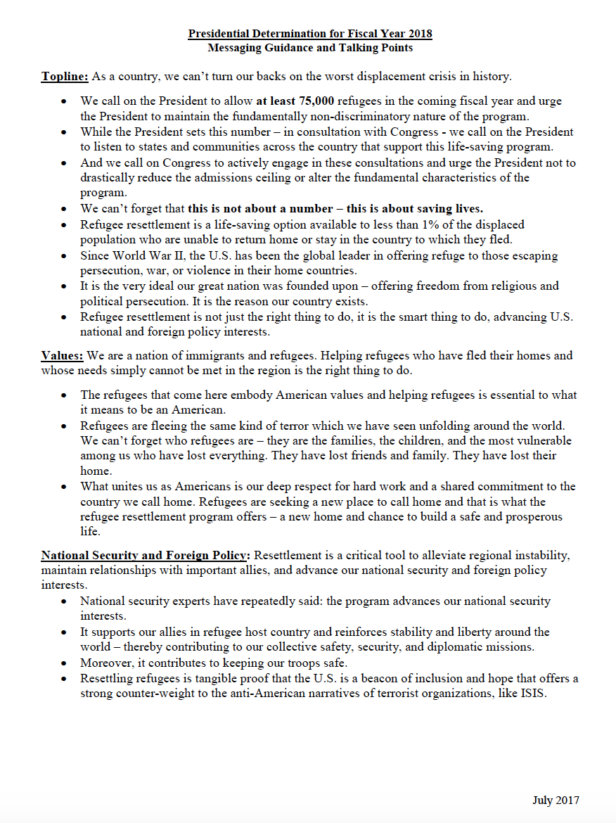

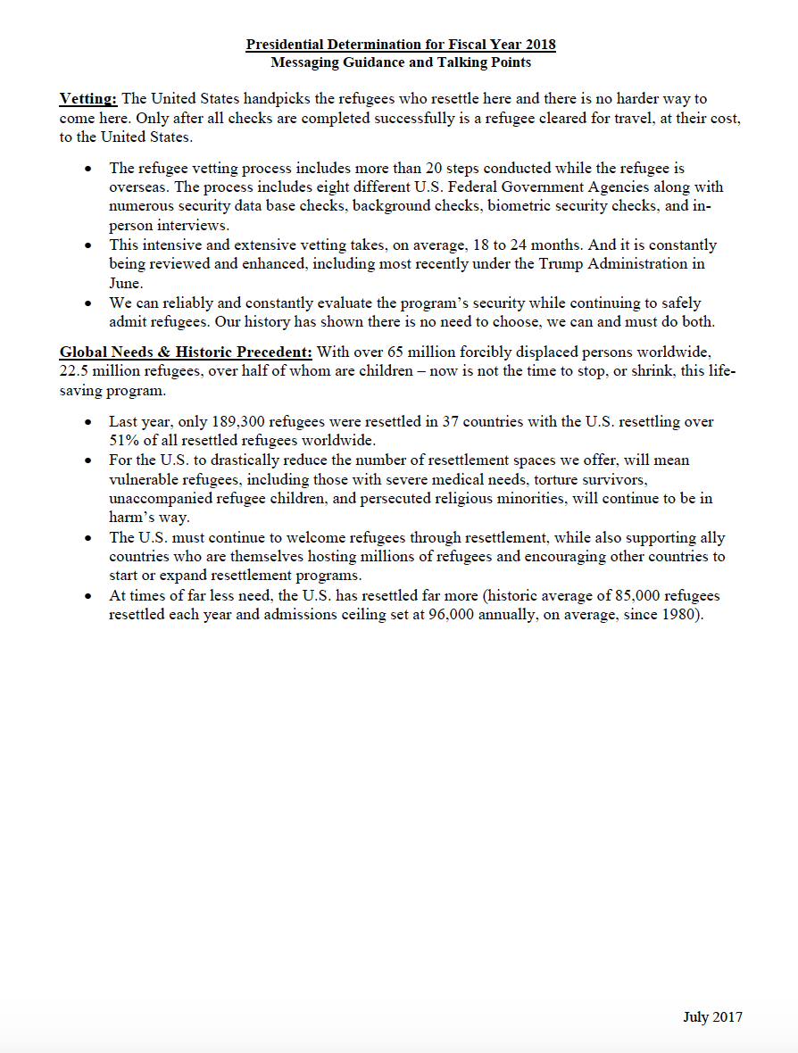
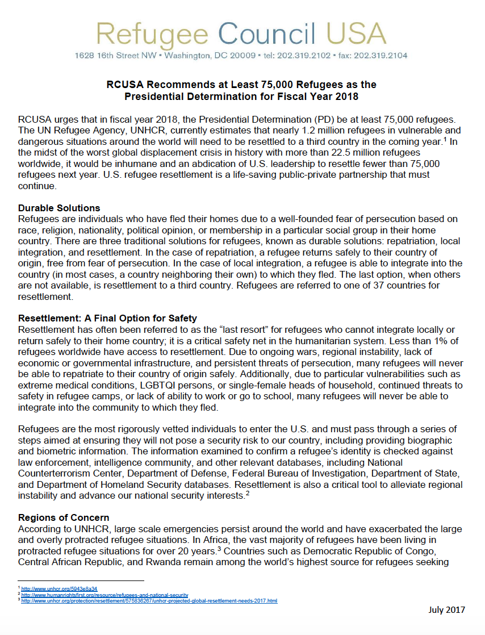

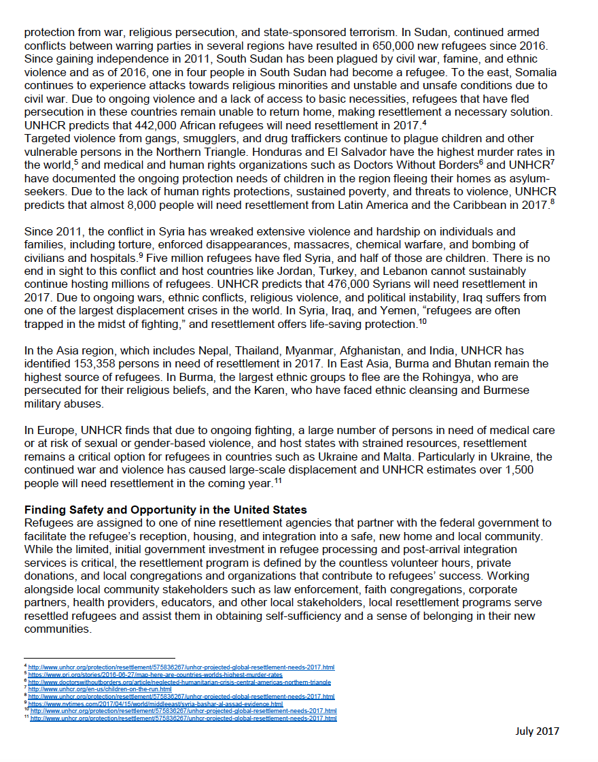

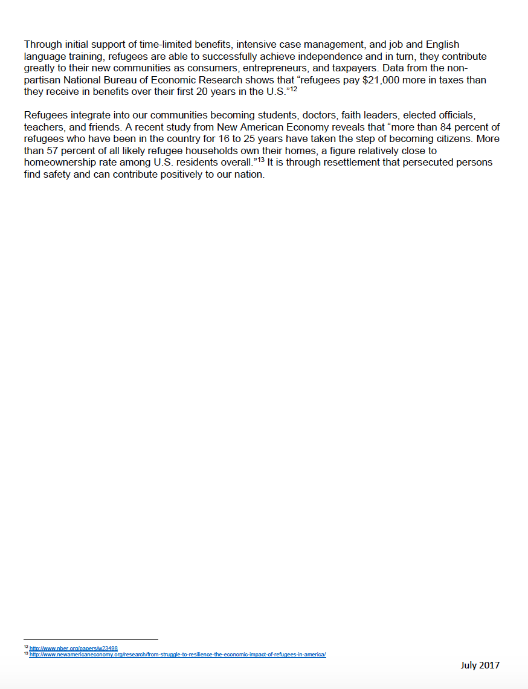

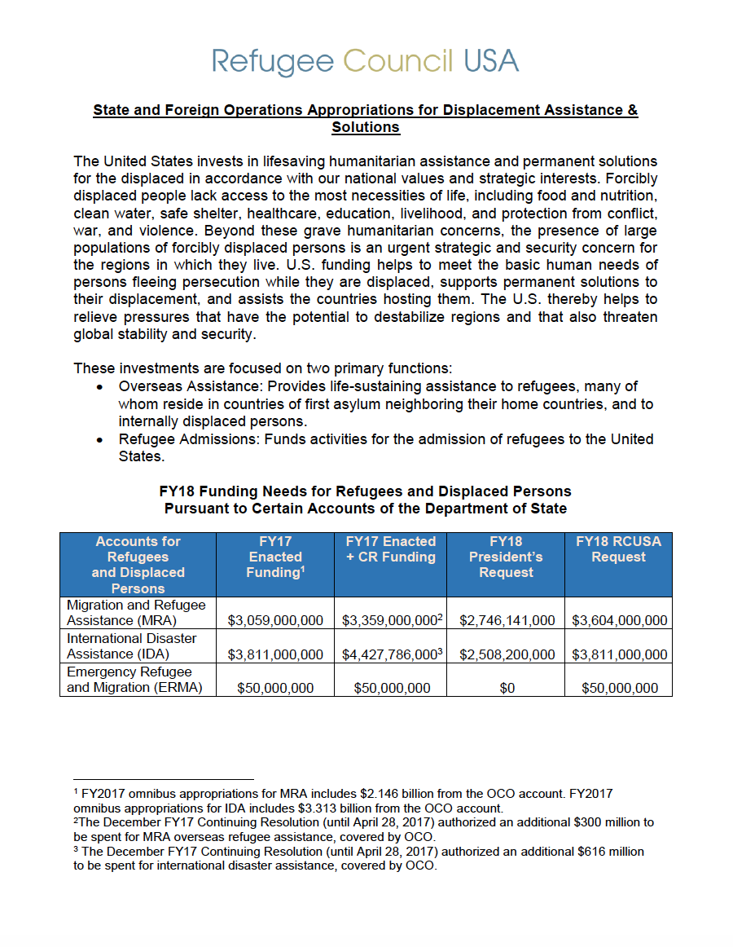
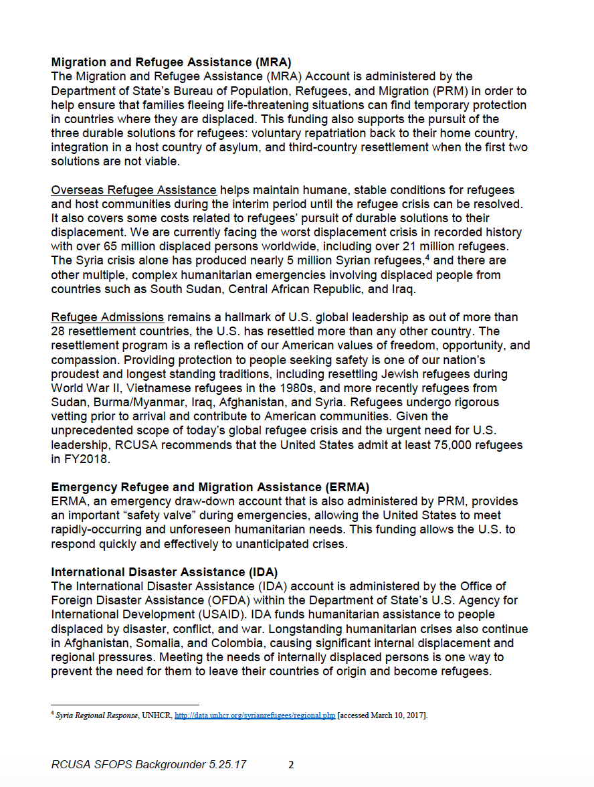
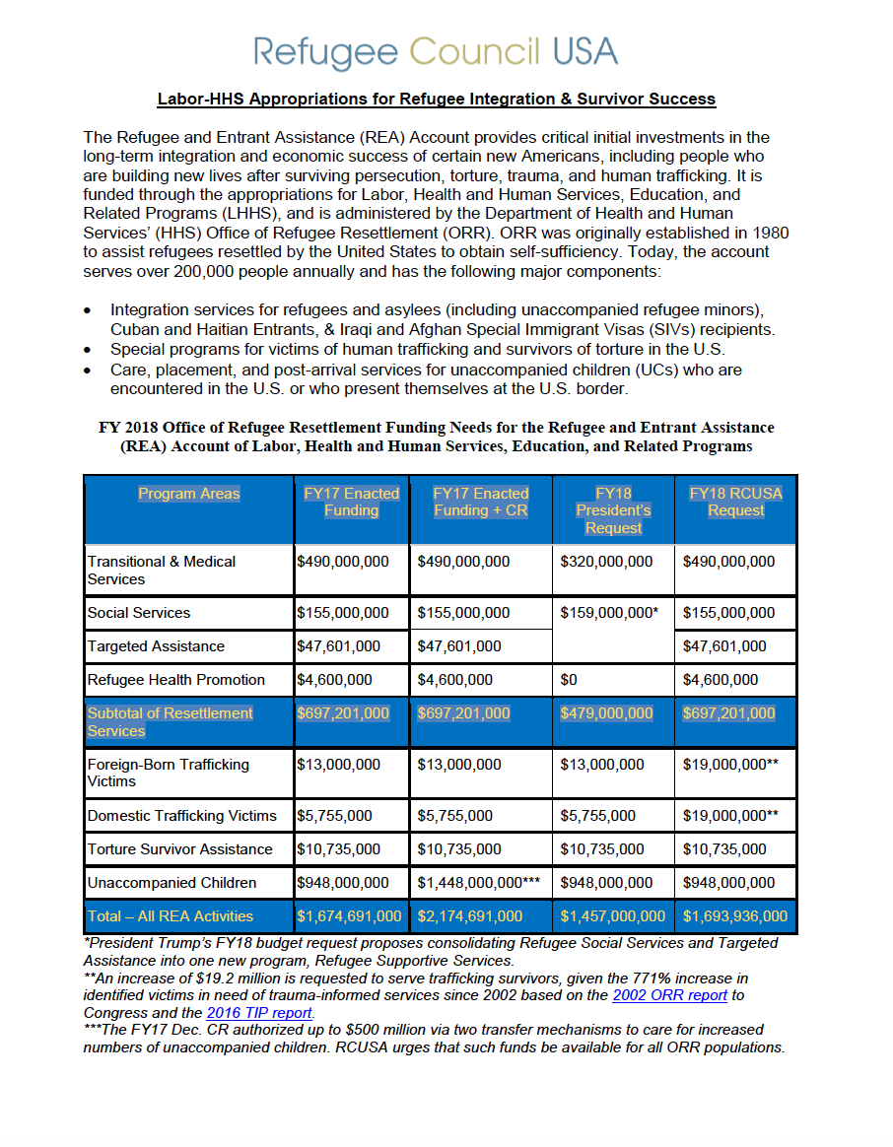
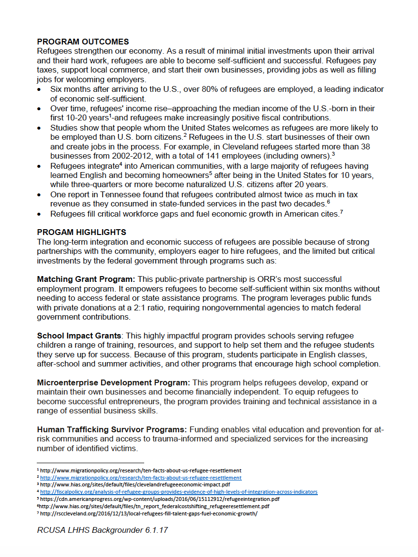
Employer Roundtable: Set Up Roundtables to Support Refugees

There are countless opportunities for you to create a team that represents an important sector of the community that supports refugees. By convening a group of individuals together to speak to their individual and collective reasons for supporting refugees in their community, you can amplify individual support for refugees into a strong unified message. We encourage you to bring together a diverse group of individuals, from all walks of life and industries, not forgetting to include refugees themselves, to meet with local and national leaders.

Your teams can hold roundtables with members of your Congressional delegation, local elected leaders, and other community leaders, all with the aim of speaking in support of the U.S. Refugee Admissions Program, and supporting our collective request of welcoming at least 75,000 refugees in fiscal year 2018.

Employers:
If you employ refugees, you know how important their contributions are to our economy – both locally and nationally. Gather other employers of refugees in your district or state and meet with your members of Congress and other elected leaders to share stories of the hard work refugees do to contribute to your business. Utilize your networks to identify and convene a large group of employers who can speak to the economic contributions of refugees. Meetings could include business owners, CEOs, managers, and former refugees who now own businesses.

Faith Leaders:
If you are a faith leader, you understand how meaningful it is to have refugees join and participate in your faith community, as well as the importance of welcoming the stranger and protecting the most vulnerable in your faith tradition. Gather leaders with diverse faith backgrounds in your district or state to share stories of the perspective and life refugees bring to your congregations and communities. Groups could include Bishops, Pastors, Imams, Priests, Rabbis, and other faith or community voices.

Veterans:
Veterans have dedicated their lives to supporting and defending the rights of Americans – including refugees. As someone who has served their country, you know that protecting the world’s most vulnerable is part of our country’s legacy and is also in the best interests of our national security. Many veterans have served alongside local persons as guides, interpreters, and more who now are seeking safety from the persecution they face due to their role in supporting U.S. troops. It’s important elected officials here these stories and continue to uphold promises to our allies who need protection. Groups could include veterans, reserve and guard forces, or active duty U.S. Armed Forces.

First Responders:
As with Veterans, first responders have dedicated their careers to saving and defending the lives of all Americans – including refugees. First responders are committed to protecting all in times of need. A group of first responders could include police officers and other law enforcement, firefighters, and emergency medical personnel in your state or district.

Diverse Group of Voices:
Alternatively, you could construct a roundtable that includes representatives from each group, demonstrating how much refugees mean to various parts of a community. You could convene employers, faith leaders, veterans, and first responders and hold roundtables with your members of Congress or elected leaders together.

Other Voices:
Don’t fit into a category above? No problem – convene a group of interested voices and schedule a meeting. It could be a group of local NGOs who work on varied issues, or just a group of concerned community members who want to tell their elected leaders why they support refugees. Just remember, bring along educational materials to leave behind with the office once you’ve met with them.
Media & Outreach Resources

Writing & Pitching an Opinion Editorial (Op-Ed)

When drafting an opinion piece, research the outlet you are submitting to. Many have a word limit between 750-1200, though some can be as low as 300 or 500. Please feel free to use the points in the draft op-ed below as you write your own opinion article, or feel free to write directly from the heart - what you have to say deserves to be heard!

When pitching your op-ed, it is important to keep your pitch short and on message. Most outlets require you to pitch via email on a form on their website. It is important to keep your pitch as short as possible, as reporters are often on a deadline and receive many story pitches every day. Open your pitch with an interesting first line and relate the pitch back to another story the reporter has recently written to increase the likelihood of the reporter picking up your story. Please see the draft pitch below for an example email.

Be sure to research the outlets and reporters in your area. Who are the top current event, immigration, or political reporters in your area? Have they written about refugees before? If so, how can you tie your event into their previous work? Answering these questions and using them to draft your pitch will help increase the chances of your welcoming event being covered and featured as an exclusive in a larger outlet.

Draft Pitch Email for Op-Ed

Subject: Submission: Faith leader op-ed on supporting refugee resettlement

Dear Editor,

My name is ______ and I’m the ______ of [organization]. As the global community faces the largest displacement crisis in history, our organization/congregation is preparing to resettle refugees and do our part to create a welcoming community. (include brief details about why you’re writing about refugees).

My experiences inspired me to author the attached op-ed, reaffirming the need for us all to work together and create an inclusive community. In light of recent anti-refugee and anti-Muslim rhetoric in particular, this piece offers a timely response and highlights the urgent need to create a welcoming place for all people.

Please feel free to contact me at EMAIL or over the phone at PHONE NUMBER if you have any questions or would like to discuss the piece in greater detail. Thank you in advance for your consideration!

Sincerely,
NAME

Sample Faith Leader Op-Ed

Welcoming Refugees: It’s a Matter of Faith

I reflect how from the earliest days of [Sunday school/Hebrew School/Seminary], my faith has taught and called me to welcome the stranger, stand with the vulnerable, and love my neighbor. Now, as a father, minister, and [Tennessean], I am proud to demonstrate these values in my daily life and weekly sermons at [name of congregation]. But it is also because of those values that I am deeply disturbed by recent anti-refugee and anti-immigrant sentiment espoused by some of our law makers. It sends an unwelcoming and mean-spirited message of exclusion to refugee families fleeing violence and persecution.

Last year, [INSERT STATE CONTEXT]. This [BILL, RESOLUTION, PROPOSAL], as well as the recent executive order to stop refugee resettlement stands opposite to my beliefs as a person of faith. Refugees are also the most scrutinized individuals entering the United States. To claim that they are security threats to our community not only ignores the unimaginable circumstances they flee and heavily scrutinized path to safe haven in the United States, but also stokes fear rather than cultivating compassion, truth, and understanding.

From the [earliest books] in the [Bible/Torah/Quran], our faith calls on us to show mercy and hospitality to those fleeing persecution. We are called to treat them with dignity, respect, and love, providing the same welcome that we ourselves would hope for.

[INSERT RELEVANT SCRIPTURE – EX: “Bring water to the thirsty, meet the fugitive with bread… For they have fled from the swords, from the drawn sword, from the bent bow, and from the stress of battle.” - Isaiah 21:14-15; “And (as for) those who believed and fled and struggled hard in Allah's way, and those who gave shelter and helped, these are the believers truly; they shall have forgiveness and honorable provision.” (Quran 8:74); “And you are to love those who are foreigners, for you yourselves were foreigners in Egypt.” (Deuteronomy 10:19)]

As Americans, we live in a country built in part by the hard work, dreams, and determination of generations of immigrants and refugees -- many of whom were our ancestors. Sadly, it seems that our legislators have forgotten these lessons and have acted with fear instead of compassion.

Today, I am asking all Members of Congress to protect funding for refugee resettlement and humanitarian assistance, reduce funding for detention and mass deportation enforcement, and work to ensure the administration recognizes the relationships refugees have with U.S.-based resettlement agencies and family members in the U.S. I also urge them to support resettling at least 75,000 refugees in fiscal year 2018.

Refugees are mothers, fathers, and children. They are doctors, teachers, lawyers, business owners, craftsmen, and musicians. As the world searches for solutions to the largest displacement crisis in history, with more than 21 million refugees worldwide, we have a moral and legal obligation to refugees seeking a chance to rebuild their lives and create a better future for their families. These people are no different than our [Biblical] ancestors who were once refugees who found welcome and were called to do the same.

I urge our elected lawmakers to ensure [State] is providing refugees a chance to live, work, and go to school in safety. To do otherwise would be to dishonor our legacy of welcome and hospitality and fall short of our values.

Sample Refugee Leader Op-Ed

Take it From Someone Who Has Been in Their Shoes: We Must Welcome Refugees

My name is [name], and I’m [career, family, etc.] I came to the United States as a refugee from [country] [time] years ago. My family and I were forced to leave everything behind after [personal story].

Today, I reflect on my journey and am so grateful to the United States and my new community for giving me another chance at life.

As with many refugees, I would have preferred to remain in my homeland. However, [share why you needed to move, and that the journey was difficult and long]. After experiencing such traumas, I faced other challenges while resettlement, such as [name a few of these challenges]. What made the biggest difference in overcoming these hardships--and in healing from past traumas--has been the welcome received when I joined my new community. [Name a few ways you were welcomed, and tell how that made you feel.]

As someone who understands the struggles of refugees firsthand, I am disheartened to see that my beloved new home is denying that same opportunity to others now facing similarly dangerous situations.

I always viewed America as a beacon of hope. The executive orders banning Muslim immigrants and refugees do not reflect that. In fact, they completely contradict the values America stands for: compassion, welcome, and resilience. The United States is a country where anyone should be able to pursue the American Dream and live in safety.

[Insert STATE specific context on refugee-related state proposals.] The fear, hate and xenophobia perpetuated by [IF RELEVANT: this state bill] and the executive order do not reflect the [STATE] and America I know. The [STATE] and America I know is compassionate in its acceptance of those seeking shelter from some of the worst conflicts in history.

Today, I am asking all Members of Congress to protect funding for refugee resettlement and humanitarian assistance, reduce funding for detention and mass deportation enforcement, and work to ensure the administration recognizes the relationships refugees have with U.S.-based resettlement agencies and family members in the U.S. I also urge them to support resettling at least 75,000 refugees in fiscal year 2018.

I continue now to believe in the importance of welcoming others--for others have welcomed me. As someone who knows firsthand the horrors that refugees flee and the sense of hope finding a home brings, I urge our local leaders, state legislators, and national policy makers to stand with refugees--today and every day. Only then will we truly reflect the welcome our country stands for.

Together, we can inspire welcome across the country and around the world.

Sample Tweets

Contributions and Benefits of Refugees in Our Communities
- [Name of group, family, etc.] is ready to welcome refugees! #RefugeesWelcome #GreaterAs1 (photo)
- My community is better with refugees. They [pay taxes, create jobs, start businesses, bring cultural diversity, open restaurants, etc.]. #RefugeesWelcome #GreaterAs1
- We celebrate the diversity and resiliency #refugees bring to our communities! #RefugeesWelcome #GreaterAs1
- Making #RefugeesWelcome involves teamwork! NGOs, faith communities, community groups & others all chip in. #GreaterAs1
- Refugees across the US add value: working, learning English, paying taxes, opening businesses & becoming citizens. #RefugeesWelcome #GreaterAs1
- Entire communities benefit from refugees, esp when we invest in welcoming early on, equipping them to thrive. #GreaterAs1
- Every year, #refugees open businesses, revitalize towns, become citizens & give back to the communities that welcomed them. #GreaterAs1
- #Refugees bring their resiliency & experiences to help make our communities better. #RefugeesWelcome #GreaterAs1

Refugee Facts
- 51% of #refugees are children. What if that was someone you know? #GreaterAs1
- Every minute, 24 people are forced to flee their homes because of war or persecution. #RefugeesWelcome #GreaterAs1
- The US has been a global leader in the protection of refugees and must continue to set an example as a safe haven. #RefugeesWelcome #GreaterAs1
- Since the passage of the Refugee Act of 1980, over 3 million #refugees have found safe haven in America. #RefugeesWelcome #GreaterAs1
- The US Refugee Resettlement Program is a lifesaving, public-private partnership for #refugees with no other means of finding safety. #GreaterAs1

Please click here for more sample social media posts.
Sample Letter to Your Members of Congress
[Date]

The Honorable [Senator/Representative] (find this information at www.senate.gov and www.house.gov)
[room number] [name of congressional office building]
Washington, DC [20510/20515]

Dear [Senator/Representative] [last name]:

As your constituent, I urge you to protect funding for refugee protection internationally and refugee resettlement in the United States and to reduce funding for detention, deportation, and border militarization, which only tears families apart. Over sixty-five million people are displaced globally, including over 22 million refugees, the largest number in recorded history. As Congress works on federal spending bills for Fiscal Year 2018, it is critical that the United States demonstrate leadership by extending international humanitarian assistance and ensuring that refugees resettled in the United States receive the welcome they need to thrive in their new communities. I also urge you to support resettling at least 75,000 refugees in fiscal year 2018. In response to the recent Supreme Court decision limiting the entry of refugees to those who have a “bona fide relationship with a person or entity” in the United States, please do everything in your power to ensure the administration recognizes the relationships refugees have with U.S.-based resettlement agencies and family members in the U.S.

Refugees are of special humanitarian concern to the United States and are a testament to our nation’s long, proud history as a beacon of hope. To be admitted to the United States, refugees must demonstrate that they have a well-founded fear of persecution because of their race, religion, nationality, political opinion, or membership in a particular social group, and must undergo rigorous security screenings, including biometric checks and interviews with specialized and well-trained Department of Homeland Security officers. The U.S. Refugee Admissions Program is a private/public partnership that is integral to U.S. foreign policy and national security.

[Local agency name] helps refugees who have been resettled in [state] by providing them with the tools of self-reliance: housing, job placement and employment skills, English-language classes, and community orientation. Refugees are resilient, hard workers whose innovative skills have contributed greatly to our state. [Describe positive impacts refugees have on your community—can include examples of refugees creating jobs, starting businesses, opening restaurants, bringing cultural diversity, buying homes, paying taxes, etc.]

Our office in [city/state] has helped resettle [X number of] refugees in the past year alone. Since the office opened in [date], over [X number of] refugees from [X number of] countries have embarked on a path to reach their full potential and enjoy safety, security, and a second chance in life. Refugees have opened businesses, revitalized towns, and become productive members of communities that welcomed them. Many become American citizens and see their children graduate from U.S. schools.

I urge you to stand with our community as we welcome refugees by increasing funds for the following accounts:
Labor / Health and Human Services:
Refugee and Entrant Assistance: $1.693 billion to ensure local communities have the resources to help refugees integrate and thrive as they rebuild their lives.

State Department / Foreign Operations:
Migration and Refugee Assistance: $3.6 billion to assist refugees abroad, and process and provide initial integration assistance to refugees resettled in the U.S.
International Disaster Assistance: $3.8 billion to respond to the growing numbers of persons internally displaced.
Emergency Refugee and Migration Assistance: $50 million to enhance the United States' ability to respond quickly and effectively to unanticipated crises, such as those in and around Syria, South Sudan, and other emerging crises.

Refugees are a testament to the United States’ long, proud history as a sanctuary for those who seek lives free from violence and oppression. I call on you to support resettling at least 75,000 refugees in fiscal year 2018; protect refugee assistance and resettlement; and reduce funding for detention, deportation, and border militarization. My community welcomes refugees and immigrants, and I invite you to meet with refugees next time you are in your home office. Thank you for your public service, and please contact me if you have any questions.

With Appreciation,
[your signature and contact information]

Sample Letter to Send to Your State and Local Leaders

[Date]

[Title] [To find your governor, state legislators, mayor, and local officials, click here]
[room number] [name of office building]
[City, State Zip Code]

Dear [TITLE Last Name]:

As your constituent from [city, state], I urge you to welcome refugees, support the U.S. refugee resettlement program, and declare our [city/county/state] a “Welcoming City.” I would also urge you to write the State Department to show your support for resettlement. Resettlement is a strong American legacy that extends hospitality and offers a chance for refugees to rebuild their lives in safety and dignity. Every day, more community members than ever before are volunteering with resettlement offices around the country to help refugees integrate and thrive.

The United States has a long history of providing protection to persons seeking safety from persecution. In the aftermath of World War II, the U.S. led humanitarian assistance efforts to help displaced persons, including resettling hundreds of thousands of Europeans to the United States, including Jewish survivors of the Holocaust. During the Cold War period, the U.S. welcomed refugees from Vietnam, Cuba and the former Soviet Union. Today, we resettle Darfuri refugees fleeing genocide, Bhutanese refugees forced out of their country, Syrian refugees who have fled mass violence and human rights atrocities, Iraqi and Afghan refugees who served alongside the U.S. military, and many other populations in need of lifesaving protection. Refugee resettlement is a public / private partnership that celebrates the hospitality, resilience, and freedom that our communities hold dear.

Refugees are forced to flee their homes because they face persecution on account of their religion, ethnicity, nationality, political opinion, or membership in a particular social group. Over 65 million people are displaced globally, the largest displacement crisis in recorded history, including over 21 million refugees. Resettlement offers a chance for less than 1% of the world’s refugees to reach safety in a third country when no other options remain. Resettlement to the United States is available only for those who demonstrate the greatest and most immediate need for protection and takes place after eligible refugees undergo a rigorous selection, security vetting and medical screening process.

[Local agency name] helps refugees who have been resettled in [state] by providing them with the tools of self-reliance: housing, job placement and employment skills, English-language classes, and community orientation. Refugees are resilient, hard workers whose innovative skills have contributed greatly to our state. [Describe positive impacts refugees have on your community—can include examples of refugees creating jobs, starting businesses, opening restaurants, bringing cultural diversity, buying homes, paying taxes, etc.]

Our community is home to a diverse population of refugees and immigrants, adding to the economic strength and cultural richness of our community. We have been an example of a hospitable and welcoming place to all newcomers, where people thrive and the contributions of all are celebrated and valued. As cities across the United States have declared themselves to be welcoming to refugees and immigrants, we urge to adopt a resolution declaring [City/County/State] a “Welcoming City,” one in which all are welcome, accepted, and appreciated.

Please stand with us as we welcome refugees and affirm the richness of our community. We invite you to come visit our office and meet with refugees [perhaps include event information]. Thank you for your public service, and please contact me about how we can be supportive of moving a welcoming resolution forward.

With appreciation,
[your signature and contact information]

SAMPLE LOCAL WELCOME RESOLUTION

RESOLUTION RECOGNIZING THE CITY/COUNTY OF [NAME] AS A WELCOMING CITY/COUNTY THAT CELEBRATES THE GROWING DIVERSITY OF ITS RESIDENTS AND ACNOWLEDGES THAT REFUGEES, IMMIGRANTS, AND ALL NEWCOMERS ENHANCE THE CULTURE AND THE ECONOMY

WHEREAS, there are more than 65 million displaced people have been forced from their homes, more than any time in recorded history, including over 21 million refugees;

WHEREAS, millions of refugees – regardless of faith or country of origin – are making life and death decisions to flee their homes and neighboring countries because they are unable to access shelter, health care, education, or protection, and neighboring countries have either closed their borders to new arrivals or violence persists in those countries as well;

WHEREAS, resettlement is available to a very small portion of the most vulnerable refugees and provides safe haven in a third country when no other options for safety are available;

WHEREAS, resettlement to the U.S. is available only for those who demonstrate the greatest and most immediate need for protection – such as unaccompanied and other at-risk children, female-headed households, victims of torture, the physically disabled, members of the LGBTI community, and members of minority groups that are experiencing oppression in the host country – and takes place after eligible refugees undergo a rigorous selection, security vetting, and medical screening process;

WHEREAS, the [City/County] of [Name] is home to a diverse population of refugees and immigrants, adding to the economic strength and cultural richness of our community;

WHEREAS, organizations responsible for resettling refugees in our community, as well as numerous other community organizations and religious institutions, have declared their support for resettling refugees in [CITY];

WHEREAS, the [City/County] of [Name] has been an example of a hospitable and welcoming place to all newcomers, where people, families, and institutions thrive and the contributions of all are celebrated and valued;

WHEREAS, cities across the United States have declared themselves to be welcoming to refugees and immigrants, joining a national movement for creating an inclusive community;

WHEREAS, residents of [City/County] of [Name] aspire to live up to our highest societal values of acceptance and equality, and treat newcomers with decency and respect, creating a vibrant community for all to live in;

NOW, THEREFORE BE IT RESOLVED BY THE CITY/COUNTY OF [NAME], that the [City/County] of [Name] is hereby declared a Welcoming City, and one that affirms the beauty and richness of our diversity, and one in which all are welcome, accepted, and appreciated.

BE IT FURTHER RESOLVED, that the [City/County] of [Name] hereby urges other local and state communities to join us in a stronger national effort to resettle the most vulnerable refugees worldwide and help them integrate and thrive.

Adopted this the X day of [Month Year].

Draft Letters for Local Officials to Send the White House & State Department

[Date]

Dear President Trump and Secretary of State Tillerson:

Welcoming refugees shines a light on Americans’ most cherished common values. As a community in [CITY, STATE], we believe in the strength of the U.S. refugee resettlement program and welcome refugees from all backgrounds, faiths, and countries of origin. This commitment reflects a core American belief in the dignity of every person, lifts up diversity as a community’s strength, and cultivates an environment of inclusion. Resettlement is a strong American legacy that extends hospitality and offers a chance for refugees to rebuild their lives in safety and dignity. Every day, more community members than ever before are volunteering with resettlement offices around the country to help refugees integrate and thrive.

Refugee resettlement is the living embodiment of the religious commitment to “welcome the stranger,” a bedrock upon which much of America’s strength rests. In our community, churches, synagogues, mosques, and other communities of faith stand in partnership to help refugees of all faiths find safety and hope as they start their lives as new Americans. The United States has a long history of providing protection to persons seeking safety from persecution. In our community, we have welcomed refugees from [describe where refugees in your community have come from and the struggles they faced on their journey to the United States.]

Refugees are forced to flee their homes because they face persecution on account of their religion, ethnicity, nationality, political opinion, or membership in a particular social group. Over 65 million people are displaced globally, the largest displacement crisis in recorded history, including over 21 million refugees. Resettlement offers a chance for less than 1% of the world’s refugees to reach safety in a third country when no other options remain. Resettlement to the United States is available only for those who demonstrate the greatest and most immediate need for protection and takes place after eligible refugees undergo rigorous selection, security vetting and medical screening processes.

The resettlement program is a prime example of a public/private partnership between the federal government, the state government, and local communities and their agencies and volunteers. [Local agency name] helps refugees who have been resettled in [state] by providing them with the tools of self-reliance: housing, job placement and employment skills, English-language classes, and community orientation. Refugees are resilient, hard workers whose innovative skills have contributed greatly to our state. [Describe positive impacts refugees have on your community—can include examples of refugees creating jobs, starting businesses, opening restaurants, bringing cultural diversity, buying homes, paying taxes, etc.]

Please stand with our community as we welcome refugees. We invite you to come visit our office and meet with refugees [perhaps include event information]. Thank you for your public service, and please contact me if you have any questions about refugee resettlement in our area.

With appreciation,
[your signature and contact information]

*Your local policy makers will know how to send correspondence to the White House and State Department. Encourage them to also send the letter to your Senators and Representative, and also please share a copy with your agency's advocacy staff, contact information on last page, so we can see how many have been sent and ensure that Administration officials and members of congress see them.

Advocacy Resources & Contact Information for Advocacy Staff

Urge your business, health, educator, law enforcement, and faith community partners to sign these letters!
- bit.ly/Business4Refugees
- bit.ly/Educators4Refugees
- bit.ly/LawEnforcement4Refugees
- bit.ly/Health4Refugees
- bit.ly/FaithLeaders4Refugees

National Sign On Letters Demonstrating Commitment to Refugees
- Letter from 5,000+ religious leaders in support of resettling refugees of all faiths: www.interfaithimmigration.org/5000religiousleaderletter
- Letter from the Evangelical Immigration Table in support of refugee resettlement: http://evangelicalimmigrationtable.com/cms/assets/uploads/2015/12/EIT-Syrian-refugee-letter.pdf
- Letter from more than 1,000 rabbis calling on elected leadership to support refugee resettlement: www.hias.org/sites/default/files/1000_rabbis_support_refugees_160115.pdf
- Letter from 4,000 + Catholic sisters, priests, and brothers in support of resettling refugees of all faiths https://justiceforimmigrants.org/news/catholic-religious-sign-letter-support-refugee-resettlement/
- Former National Security Officials Statement on America’s Commitment to Refugees: www.human rightsfirst.org/sites/default/files/STATEMENT-ON-AMERICAS-COMMITMENT-TO-REFUGEES.pdf

Security Screening and Refugee Processing Backgrounders
- Department of Homeland Security Refugee Screening Fact Sheet: www.uscis.gov/sites/default/files/ USCIS/Refugee,%20Asylum,%20and%20Int'l%20Ops/Refugee_Security_Screening_Fact_Sheet.pdf
- Department of Homeland Security USRAP Flow Chart: www.uscis.gov/sites/default/files/USCIS /Humanitarian/Refugees%20%26%20Asylum/USAP_FlowChart_V9.pdf

State-by-State Resources
- RCUSA State Profiles on Refugee Resettlement: www.rcusa.org/state-refugee-profiles
- Interfaith Immigration Coalition State-by-State Articles and Demonstrations of Welcome: www.interfaithimmigration.org/2015/12/03/welcoming-refugees-state-by-state-resources/

Additional Advocacy Toolkits
- USCCB World Refugee Day 2017 Toolkit: https://justiceforimmigrants.org/2016site/wp-
- Interfaith Immigration Coalition Neighbor-to-Neighbor Toolkit: www.interfaithimmigration.org/neighbor
- Refugees Welcome Toolkit: www.refugeesarewelcome.org/refugees-welcome-toolkit_final-8-5-16/
- My Neighbor is Muslim Toolkit: http://lirs.org/myneighborismuslim/

Executive Order Against Refugees and Muslims
- Talking Points, Section-by-Section, Asks for Members of Congress: https://docs. google.com/document/d/1UX73gwC7JH7i1DXeDREvqpE71o4h3NFso5az33Bt2uk/edit?usp=sharing
- FAQs on President Trump’s Refugee Executive Order: https://docs.google.com /document/d/1JA_14yqO7Mi4SK3p-yqROpg2N13PEvhnpfd-LpLeJTE/edit?usp=sharing

The following advocacy staff represent organizations working with refugees:
- Church World Service: Jen Smyers, jsmyers@cwsglobal.org
- Episcopal Migration Ministries: Lacy Broemel, lbroemel@episcopalchurch.org
- HIAS: Liz Mandelman: elizabeth.mandelman@hias.org
- International Rescue Committee: Kristen Aster, kristen.aster@rescue.org
- Lutheran Immigration and Refugee Service: Ryan Mace, RMace@lirs.org
- U.S. Conference of Catholic Bishops: Matt Wilch, mwilch@usccb.org
- U.S. Committee for Refugees & Immigrants: Esmeralda Lopez, elopez@uscridc.org
- Ethiopian Community Development Council: Solace Duncan, sduncan@ecdcus.org
- World Relief: Jenny Yang, jgyang@worldrelief.org
- Jesuit Refugee Service/USA: Giulia McPherson, gmcpherson@jesuits.org
- Refugee Council USA: Shaina Ward, sward@rcusa.org

